St Gregory’s Catholic Primary School
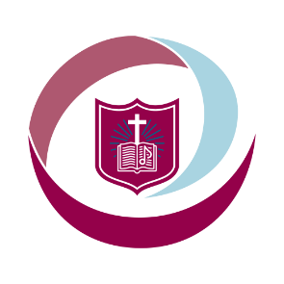
‘Loving and Learning’
The St Gregory’s Curriculum

Early Years Foundation Stage
(EYFS)

Curriculum Intent for EYFS
In EYFS at St Gregory's we aim to provide all children with a high-quality foundation to learning. We aim to create a happy, safe and nurturing environment where children can grow as independent learners. Using our expertise and the children’s interests we aim to provide our children with a curriculum which is engaging and exciting to motivate a love of learning. We strive to create an environment where children develop resilience, friendships and positive relationships. We ensure that learning is accessible for all and that children’s individual progress is valued. We will continue to develop our setting by providing a stimulating indoor and outdoor environment where children safely explore risks and challenge their own learning. We want to work closely and collaboratively with parents in order to ensure we value home experiences and develop a true reflection of the whole child.

Curriculum Implementation for EYFS
In EYFS at St Gregory’s, we follow the guidance from the Early Years Statutory Framework. This Framework specifies the requirement for learning and development in the Early Years and provides prime and specific areas of learning we must cover in our curriculum.
Prime Areas
• Personal, Social and Emotional Development
• Physical Development
• Communication and Language development
Specific Areas
• Literacy
• Mathematics
• Understanding the World
• Expressive Arts and Design
We also incorporate the characteristics of effective learning (COEL) into all teaching and learning experiences. Through short observations and interactions with children we are able to find how each individual child learns best and act upon this accordingly.
We plan and deliver a themed based curriculum to enhance children’s learning experiences and love of learning. We plan this using the children’s interests and knowledge of the KS1 curriculum in order to build the children’s knowledge of our whole school curriculum.
Parents are regularly informed about their child’s progress through parent’s meetings, our online assessment database (2Simple) and they are provided with the expectations and requirements needed to meet the age-related expectations.

Curriculum Impact EYFS
Through the delivery of a well-planned, child-led and challenging curriculum we aim that the pupils will leave the Early Years Foundation Stage as independent learners, with transferrable skills needed to start Key Stage One. This will be measured at the end of Reception as to whether the pupils have achieved a Good Level of Development. We aim that our pupils will leave our Foundation stage ready for the next stage in their education and ready for year 1 by:-
• Using their phonics knowledge to read accurately with increasing speed and fluency.
• Write correctly punctuated simple sentences.
• Understanding and using early numbers
• Having good personal, physical and social skills.
• Enjoying, listening attentively and responding with comprehension to familiar stories and rhymes.
• Demonstrating positive attitudes to learning through high levels of curiosity, concentration and enjoyment. Children will listen intently and respond positively to adults and each other.

